Chapter 9 Notes
Stoichiometry

Chemical Equations
Coefficients in equations can tell us several things
- They can tell us the of atoms that react

2H₂+O₂ 2H₂O
- molecules of hydrogen react with molecule of oxygen to give molecules of water
- How many molecules of hydrogen are required to react with 3 molecules of oxygen?

Mole Ratios
2H₂+O₂ 2H₂O
- How many molecules of hydrogen are required to react with 6.022x10²³ molecules of oxygen?

The coefficients in a chemical reaction give the ratio of of substances as well as molecules

4Al(s)+3O₂(g)→2Al₂O₃(s)

For every moles of aluminum, moles of aluminum oxide are produced

For every moles of aluminum oxide produced, moles of oxygen gas are consumed

How many moles of O₂ are produced by the decomposition of 5.8 moles of water?

5.8 moles H2O

How many moles of oxygen are required to react with 4.30 moles of propane according to the unbalanced reaction below?
C₃H₈(g) + O₂(g) CO₂(g) + H₂O(g)

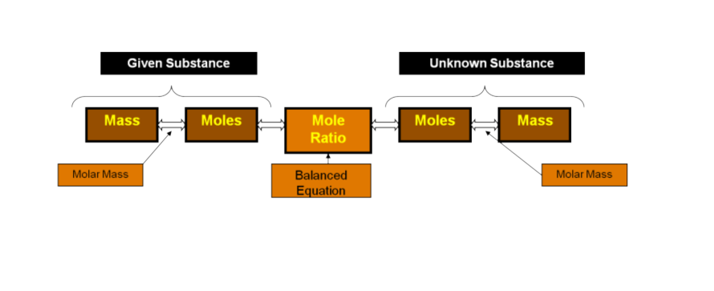
4Al(s)+3O₂(g)→2Al₂O₃(s)

What mass of oxygen is required to react completely with 43.5g of aluminum?

Determine starting and ending points
Starting:
Ending:

It is critical to keep track of substance now

2NaOH(aq) + CO₂(g) Na₂CO₃(aq) + H₂O(l)

Calculate the mass of carbon dioxide gas that is required to react with a solution containing 10.0g of sodium hydroxide

Calculate the mass of sodium carbonate that is produced when 10.0g of sodium hydroxide reacts completely

For the unbalanced equation:
P₂O₅ + H₂O → H₃PO₄
How many moles of H₃PO₄ are produced if 15.4g P₂O₅ react completely?

What mass of P₂O₅ is required to obtain 12.3g of H₃PO₄?

If 4.9 moles of P₂O₅ react with water, what mass of H₃PO₄ will result?

Homework: pg 310 (5, 8, 15, 17, 25)

Homework 2: worksheet

Homework 3: worksheet

Limiting Reactants
All of the reactions we have looked at so far have reacted completely meaning there was just of each reactant

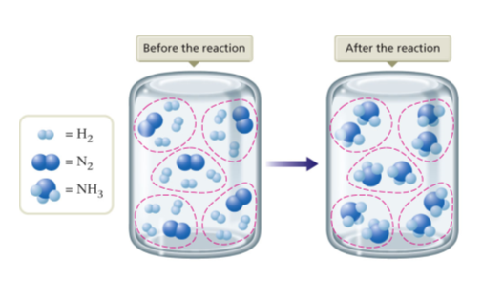

What if there is more than you need of one reactant?
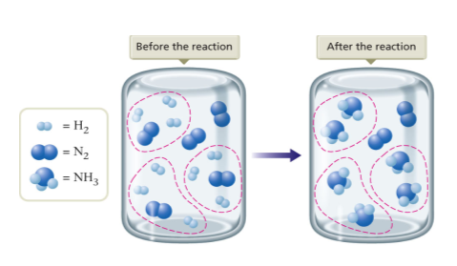
- Reactant—the substance which limits the extent of the reaction and
therefore determines the amount of formed
- Reactant--reactants left over after a reaction has gone to completion

  - In your car engine, octane reacts with oxygen. Which would be the limiting
reactant? (which do you run out of first?)

To determine the limiting reactant:
- Find the moles (or grams) of that each could produce (two different conversions)

- You must find the product!!!

- Whichever one produces grams of product is the reactant

What is the limiting reactant when 100.0gNa reacts with 100.0gFe₂O₃ according to the reaction:
6Na+Fe₂O₃→3Na₂O+2Fe

Limiting Reactant is

Excess Reactant is

How much iron would you expect to get from the reaction?
This is referred to as the yield because this is what you should get.

If 5.00g Ni and 2.50g HCl react, determine the limiting reactant, and the theoretical yield of NiCl₂ according the the equation:
Ni+2HCl→NiCl₂+H₂

Homework: pg 312 (29, 32, 35, 37, 38)

Next day homework: Worksheet

Percent Yield

yield—the maximum amount of product which can be produced from a given amount of reactant
from the balanced equation using stoichiometry

yield—the amount of product actually produced when an experiment is performed
Determined experimentally (given in a problem)

Percent yield= x

When excess potassium chromate is added to a solution containing 0.500g of silver nitrate, solid silver chromate and potassium nitrate is formed.

What is the theoretical yield of silver chromate?

If 0.455g of silver chromate form, what is the percent yield?

Percent yield is never 100% Why do you think this is?

Homework: pg 313 (40, 42, 44, 45, 46)

