Chapter 8
Reactions in aqueous
solution
When do reactions occur?
Driving forces behind reactions

1. Formation of a

2. Formation of

3. Transfer of

4. Formation of a

Formation of a solid
Precipitation reaction-a reaction in aqueous solution in which a is formed

Precipitate-a solid that forms from two solutions
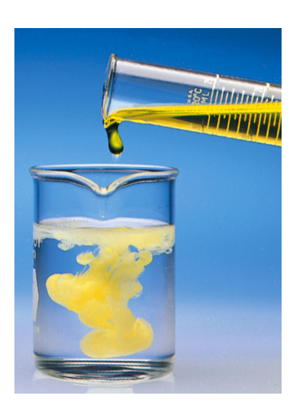

Dissolving Process
When ionic compounds dissolve in water, the ions (split apart)
Ba(NO₃)₂ splits into Ba²⁺, NO₃⁻, NO₃⁻
These mobile ions are what allow ionic compounds to electricity
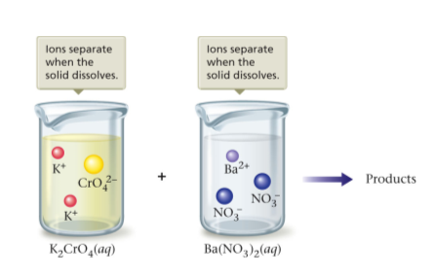

Strong electrolyte-a substance which dissociates in water and can carry an electric current

Solubility
Amount of a substance that can at a given temperature
solubility varies by

solid-a solid that is readily dissolved in water

or soluble solid- a substance in which a very tiny (undetectable) amount will dissolve

Determining Solubility
Solubility Rules

- All group 1 and NH₄⁺ compounds are

- All nitrates are

- All halides are , except Ag⁺, Pb²⁺, and Hg⁺

- All sulfates are except Ba²⁺, Ca²⁺, and Pb²⁺

- All carbonates, sulfides, and phosphates, except those of group 1 and NH₄⁺ are

- Most hydroxides are except group 1 and ammonium hydroxides

In a reaction of AgNO₃(aq) and KCl(aq) a solid forms, what are the possible
products?
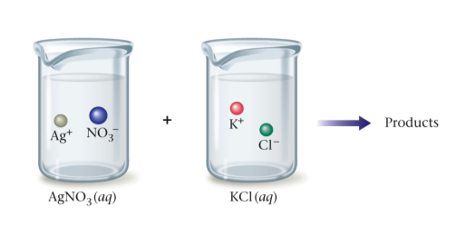
 | NO₃⁻ | Cl⁻
Ag⁺
K⁺

Two of these can be immediately ruled out. Why?

Which (if any) of the possible products would form a precipitate?

Double Displacement Reactions
Another name for reactions because ions "switch partners"

if either of the new pairings is , a precipitate will form

AgNO₃(aq) + KCl(aq)

Does the reaction occur and, if so, what are the precipitate(s)?

AgNO₃( )+KCl( ) AgCl( )+KNO₃( )

Na₂SO₄( ) + Pb(NO₃)₂( ) 2NaNO₃( ) + PbSO₄( )

KNO₃( ) + BaCl₂( ) Ba(NO₃)₂( ) + 2KCl( )

Balance the following, then predict the states of all substances and determine what the precipitate(s) will be or if there is no reaction

Ba(NO₃)₂( ) + K₃PO₄( ) KNO₃( ) + Ba₃(PO₄)₂( )

Na₂SO₄( ) + KCl( ) NaCl( ) + K₂SO₄( )

3KOH ( ) + Fe(NO₃)₃ ( ) 3KNO₃( ) + Fe(OH)₃( )

Homework: Worksheet

Ionic Equations

- Molecular Equation:

Pb(NO₃)₂(aq) +K₂CrO₄(aq) → PbCrO₄(s) +2KNO₃(aq)

- Complete ionic equation—shows all ions before and after a reaction
  - , , do not form ions

  - ions—ions which exist in the same form on both sides of an equation

and

- Net ionic equation—shows only the ions which react and change; spectator ions are left out

MgSO₄(aq)+2NaOH(aq)→Mg(OH)₂(s) + Na₂SO₄(aq)

NaCl(aq) + AgNO₃(aq) NaNO₃( ) + AgCl( )

KOH( ) + Fe(NO₃)₃( ) KNO₃( ) + Fe(OH)₃( )

Using your solubility rules, predict the state of the products of the following, balance the
equation and write the complete and net ionic equations

AuCl₃(aq) + AgNO₃(aq) → Au(NO₃)₃( ) + AgCl( )

Mg(NO₃)₂(aq) + NaCl(aq) → MgCl₂( ) + NaNO₃( )

Homework: Worksheet

Using your solubility rules, predict the states of the products of the following and write the net ionic equation

NaOH(aq) + CaBr₂(aq) → NaBr( ) + Ca(OH)₂( )

Na₂SO₄(aq) + 2 KCl(aq) → NaCl( ) + K₂SO₄( )

Homework: Worksheet

Acids
Acid-a substance which produces ions when dissolved in water
HCl

HNO₃

H₂SO₄

Acids-acids which dissociate completely in solution and are therefore strong electrolytes
, , , and others are strong acids

Bases
Base-a substance which generates ions in solution

NaOH

KOH

Strong base-a base which ionizes in solution
hydroxides are the strong bases we will be concerned with at this point

Reactions that form water
Write a complete and net ionic equation for the reaction of any strong acid with
any strong base?

What is your net ionic equation?

What is common substance is formed from the reaction?

Acid-base reaction-the reaction of a strong acid with a strong base in which will always be a product

pg 256 example 8.4

Summary of Strong Acids and Strong Bases
1. The common acids are aqueous solutions of HCl, HNO₃, HClO₄, and H₂SO₄.
2. A strong acid is a substance that dissociates (ionizes) in water (into H⁺ ions and anions).
3. A strong base is a metal hydroxide compound that is very in water (and dissociates into OH– ions and cations).
4. The net ionic equation for the reaction of a strong acid and a strong base is always the same: it shows the production of .
5. In the reaction of a strong acid and a strong base, one product is always and the other is always an ionic compound called a , which remains dissolved in the water. This salt can be obtained as a solid by evaporating the water.
6. The reaction of H⁺ and OH– is often called an acid-base reaction, where H⁺ is the ion and OH– is the ion.

Homework: Worksheet

Oxidation-Reduction Reactions
Driving force - transfer of

When we wrote formulas of ionic compounds, we found that sodium lost an electron to become and chlorine gained an electron to become

What actually happens is that sodium an electron to chlorine

Oxidation-reduction (redox) reaction - a reaction that involves a of
Oxidation-when a substance electrons
when the oxidation number (charge) becomes more

Reduction-when a substance an electron
the oxidation number becomes more

An individual element always has an oxidation number of

When compounds form from their elements a transfer of electrons always
accompanies this process
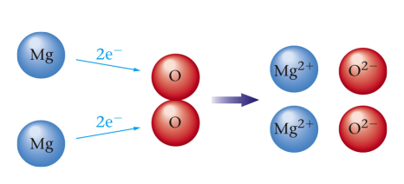
This can be written as a series of equations:

Since magnesium is losing electrons it can be written as:

Mg

Oxygen is gaining 2 electrons and can therefore be written as :

O +

Types of redox reactions
Synthesis - reactants form a product

2H₂ + O₂ H₂O

Decomposition - reactant breaks down into products

2HgO Hg + O₂

displacement - one element replaces another in a compound

Zn + 2HCl ZnCl₂ + H₂

Combustion reaction - when a compound reacts with (O₂) and produces heat and/or light
aka

as with propane below, when a hydrocarbon burns completely it always produces and

C₃H₈(g) + 5O₂(g) → 3CO₂(g) + 4H₂O(g)

Homework: Worksheet
What to Look For
Precipitation reaction - must have an or soluble product

Acid-Base reaction - must have an and a and produce

Oxidation - reduction reaction synthesis - more than 1 , 1

Decomposition - 1 , more than 1

Single replacement - different single element in and

Combustion - substance +

Homework: Worksheet

