Chapter 16 Notes
Acids and Bases

General Characteristics

Acids
- Taste
- vinegar, fruits

Bases
- taste
- feel
- most and drain cleaners

Arrhenius definition

Acids produce ions in water

HCl(g) H⁺(aq) + Cl⁻(aq)

Bases produce ions in water

NaOH(s) Na⁺(aq) + OH⁻(aq)

Some bases don't contain ions

Bronsted-Lowery definition

Acids-proton

- HCl + H₂O H₃O⁺ + Cl⁻

- HCl donates a proton (H⁺) to water
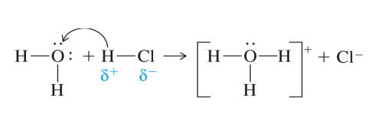
Bases-proton

- NH₃ + H₂O NH₄⁺ + OH⁻

Could Cl⁻ accept a proton?
Could NH₄⁺ donate a proton?

Conjugate Acids and Bases

A conjugate acid is formed when a base a proton

A conjugate base is formed when an acid a proton

HNO₃ + H₂O H₃O⁺ + NO₃⁻
acid base conj. conj.

Conjugate acid-base pair-two substances related to each other by the donating and accepting of a single

What is the conjugate acid of the following bases?
- SO₄²⁻
- OH⁻
- NH₃
- Br⁻

Any time water acts as a base, the conjugate acid is H₃O⁺ which is called a ion

Which of the following show a conjugate acid-base pair?
- HF/F⁻
- NH₄⁺/NH₃
- HCl/H₂O
- HClO₄/ClO₃⁻
- HCl/ClO⁻
- H₂PO₄⁻/HPO₄²⁻
- HNO₃/NO₃⁻

Write an equation in which the following react with water in the manner indicated

O²⁻ acting as a base

HSO₄⁻ acting as an acid

Homework: pg 537 (1, 2, 5, 7, 9, 11, 13, 15)

Strength of Acids

Let us look at a generic acid dissociation equation:

HA + H₂O H₃O⁺ + A⁻

As soon as HA begins to dissociate we have two bases which can accept that proton: and

- This means that the equation can also run the opposite direction
H₃O⁺ + A⁻ HA + H₂O

- If H₂O is a more effective base then which way will the reaction go?
- If A⁻ is a more effective base, which way will it go?

If the forward reaction predominates:

HA + H₂O H₃O⁺ + A⁻

- We refer to it as a acid because it will completely in solution

If the reverse reaction predominates:

H₃O⁺ + A⁻ HA + H₂O

- we refer to the acid as a acid because it is not able to donate all of its protons

- A acid is an acid which dissociates completely in solution
- A acid is one which does not dissociate completely

- Will the forward or reverse reaction generate more ions in solution?

- Will a strong or weak acid conduct electricity better?

- Often the reaction of a weak acid is written with an arrow going directions:
- HA + H₂O ⇌ H3O⁺ + A⁻

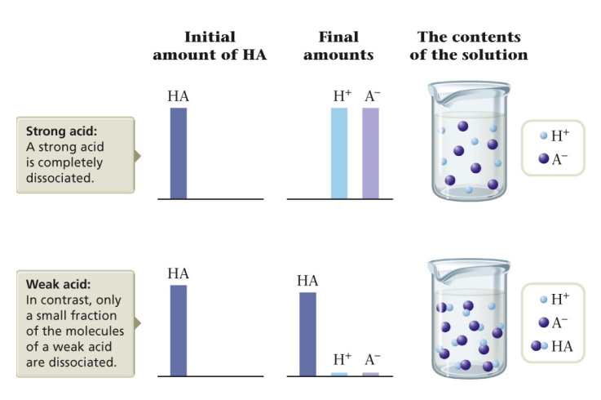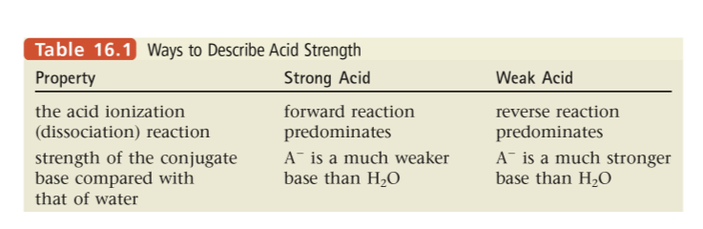
If an acid is strong, which is a stronger base H₂O (base) or A⁻(conjugate base)?

HA + H₂O ⇌ H₃O⁺ + A⁻

If an acid is weak which is a stronger base A⁻ or H₂O?

Conjugate bases of strong acids are than water

Conjugate bases of weak acids are than water

acid-An acid with two hydrogen ions that can be donated
- H₂SO₄ is a acid
  - H₂SO₄ + H₂O H₃O⁺ + HSO₄⁻

- HSO₄⁻ is a acid
  - HSO₄⁻ + H₂O ⇌ H₃O⁺ + SO₄²⁻

What type of acid is H₃PO₄ ?

-the acidic hydrogen is attached to an oxygen atom
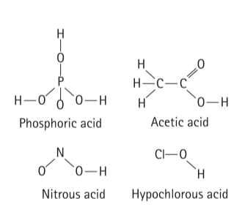

acids-a carbon compound containing a carboxyl group ( )

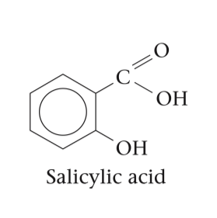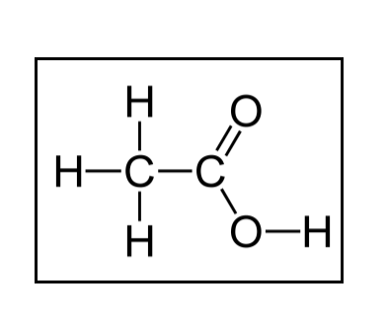
Amphoteric substances

In the equation:
HCl + H₂O H₃O⁺ + Cl⁻
is water functioning as an acid or a base?

In the equation:
NH₃ + H₂O ⇌ NH₄⁺ + OH⁻
is water functioning as an acid or a base?

In fact in the equation:
H₂O + H₂O ⇌ H₃O⁺ + OH⁻
is water functioning as an acid or a base?

substance-a substance which can behave as either an acid or a base

In the self-ionization of water:
H₂O + H₂O ⇌H₃O⁺ + OH⁻
we find that the concentrations of H₃O⁺ and OH⁻ are the same

[H₃O⁺]=[OH⁻]=

We find that the product of [H₃O⁺] and [OH⁻] is always a constant
[H₃O⁺][OH⁻]=(1.0x10⁻⁷M)(1.0x10⁻⁷M)=
Ion Product (K_{w})=

This means that no matter what is dissolved in water,
[H₃O⁺][OH⁻] =1.0x10⁻¹⁴

- Neutral solution- [H₃O⁺] [OH⁻]

- Acidic solution- [H₃O⁺] [OH⁻]

- Basic solution- [H₃O⁺] [OH⁻]

In each case, K_{w}=[H₃O⁺][OH⁻]=

Calculate the [H⁺] if the [OH⁻] is 1.0x10⁻⁵M

Calculate the [OH⁻] in a solution with [H⁺] of 10.0M

Calculate the [H⁺] if the [OH⁻] is 1.0x10⁻⁷M

Calculate the [H⁺] in a solution with [OH⁻] of 2.0x10⁻²M

Are each of these solutions acidic, basic, or neutral?

1st
2nd

Homework: pg 537 (17, 18, 25(HBrO4 is strong), 28, 30, 31, 33, 36)

pH

pH means of hydrogen

Note that all of your hydronium concentrations have a exponent

This represents a scale of about 1 units from 1x10⁻¹⁴ to 1

A scale better encompasses this range

What is the hydronium concentration of pure water?

What is the pH of pure water?

7.0 is a pH
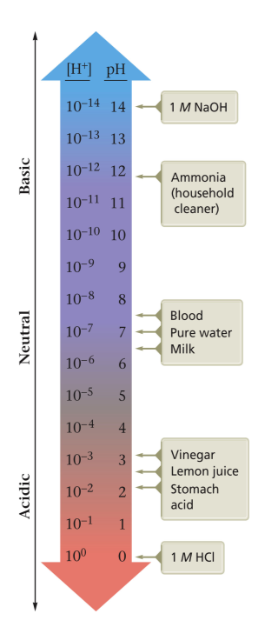

Significant digits for pH
- The pH should have the same number of places as the concentration has s.d.

Calculate the pH for the following solutions

- A solution in which [H⁺]=1.0x10⁻³M

- A solution in which [OH⁻]=5.0x10⁻⁵M

The greater the [H₃O⁺] the lower the pH will go

Acids have a
Bases have a

Calculate pH if [H₃O⁺]=5.0x10⁻³M

Is a solution of 0.20M [H₃O⁺] acidic, basic or neutral?

pH=

What is the pH of a solution containing an [OH⁻] of 2.0x10⁻³M? Is this acidic, basic or neutral?

pH=

pOH

What is the pH and pOH of the following?

- 1.0x10⁻³M OH⁻

  - pOH=
  - pH=

- 1.0MHCl

  - pH=
  - pOH=

Concentration from pH

Remember that the inverse of a logarithm is 10^{x}

What is the hydronium ion concentration in fruit juice with a
pH of 3.3?

A commercial window cleaning liquid has a pH of 11.7. What
is the hydroxide ion concentration?

Normal human blood has hydroxide ion concentrations of 1.7x10⁻⁷M to 3.5x10⁻⁷M, but diabetics often have readings outside that range. A patient’s blood has a pH of 7.67. Is there cause for concern?

[OH⁻]=

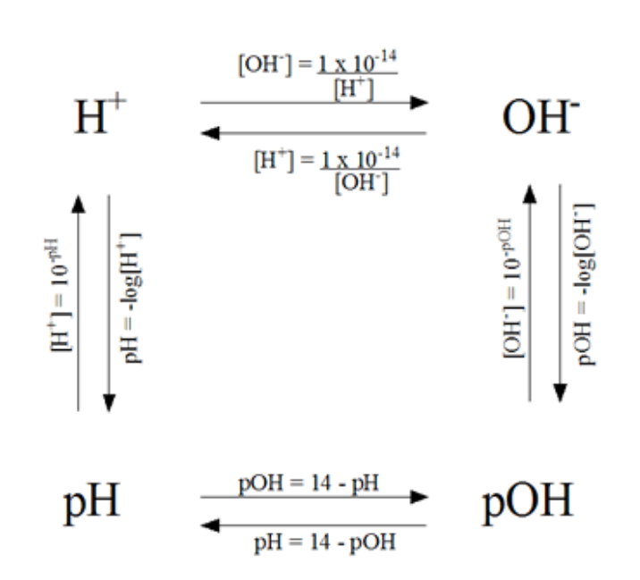

Homework: pg 538 (39, 41, 43, 49, 51, 53, 54)

Homework: pg 540 (65-68, 71, 73-76, 80-82, 88, 90, 92, 96, 99, 100, 102)

pH of Strong Acids

Remember that strong acids dissociate completely
- What concentration of [H⁺] would be found in 1.34M HNO₃?

- What is the pH of this [H⁺] concentration?

- What is the pH of 5.0x10⁻³M HCl

Indicators

—a chemical that can reversibly change color depending on the pH of the solution or other chemical change

At a certain pH, the chemical will change

has several different indicators on it which will change colors at different pH’s so you can determine the approximate pH of a solution

—measures the voltage between two electrodes to determine the exact pH of a solution

Titration
Remember acid-base reactions?

As an acid is added to a base, at some point all of the OH⁻ is used up and the neutralization reaction ends

point—the point at which a neutralization reaction is complete

With a strong acid and strong base, the pH is at the equivalence point

curve—a graph of pH vs. volume of titrant added
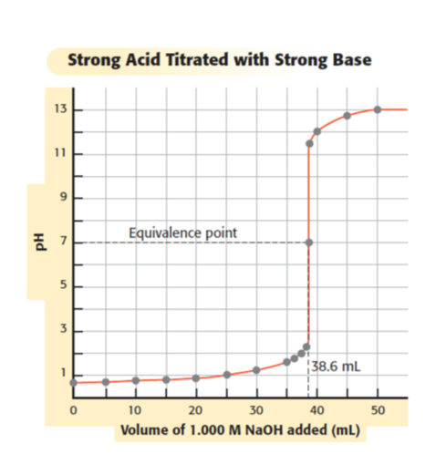
—the gradual addition of one solution to another to reach an equivalence point

One solution is of concentration

One solution is of concentration called the

Calculations
at the endpoint the pH=7 which means

Keep in mind that your acid is [H⁺] and your base is [OH⁻]

If 20.6mL of 0.010MHCl is required to titrate 30.0mL of an aqueous solution of NaOH to the equivalence point, what is the molarity of the NaOH solution?

Titrating a sludge sample of unknown origin required 41.55mL of 0.1125M NaOH. How many moles of H₃O⁺ did the sample contain?

Neutralizing 5.00L of an acid rain sample required 11.3mL of 0.0102M Ca(OH)₂. Calculation the hydronium ion concentration in the rain sample.

Homework: Worksheet
Buffers

Buffer solution—a solution made from a acid and its base that neutralizes small amounts of acids or bases added to it to
keep pH relatively

CH₃COOH(aq) + H₂O (l) ⇌ CH₃COO⁻(aq) + H₃O⁺(aq)

What happens when HCl is added to the buffer?
HCl + CH₃COO⁻ CH₃COOH + Cl⁻
does the [H⁺] increase significantly?

What happens if NaOH is added to the buffer?
NaOH + CH₃COOH NaCH₃COO + H₂O
does the [OH⁻] increase significantly?

Blood is buffered by a buffer solution

This buffer maintains blood at a pH of about ±

If your food label indicates the presence of it is probably a H₂PO₄⁻/HPO₄²⁻ buffer to maintain pH
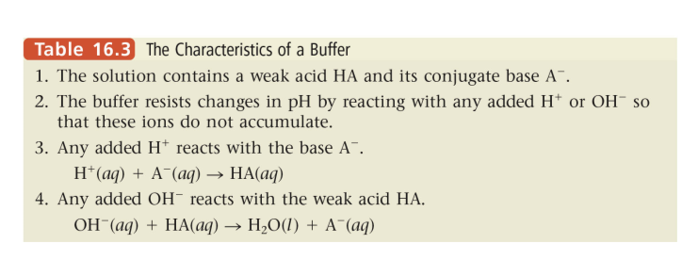
Which of these combinations would be a valid
buffer solution?

HNO₃/NO₃⁻

NH₃/NH₄⁺

CH₃NH₂/CH₃NH₃⁺

Homework: pg 540 (59-64)

