Chapter 14

Intermolecular Forces

- forces—forces which hold atoms together in a bond (ionic, covalent)

- forces—electrostatic attractions between molecules
  - than bonds which hold molecules in a covalent compound together

- Determines properties such as of
matter
Dipole-Dipole Forces

- Partial area of one molecule attracts the partial area of another molecule

- The stronger the (difference in electronegativity), the the attraction

- Similar to ionic bonds but much

- Occurs only in covalent molecules
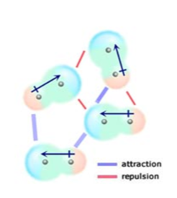

Hydrogen Bonds

- when hydrogen is bonded to a strongly electronegative element, its single electron shifts from the nucleus

- As a result the single-proton nucleus of hydrogen is
left

- Any region of another molecule can then
attract to the hydrogen

- Form when hydrogen bonds to (NOF)

- than dipole-dipole forces
- Occurs only in molecules
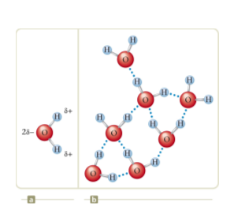
London Dispersion Forces

- bond which forms when electrons randomly end up concentrated on one side or the other of a molecule

- These temporary dipoles then a dipole on surrounding molecules

- Fairly forces of attraction

- Occur in and molecules

- Allows molecules to attract

- in atoms or molecules with more electrons
(larger molecules)

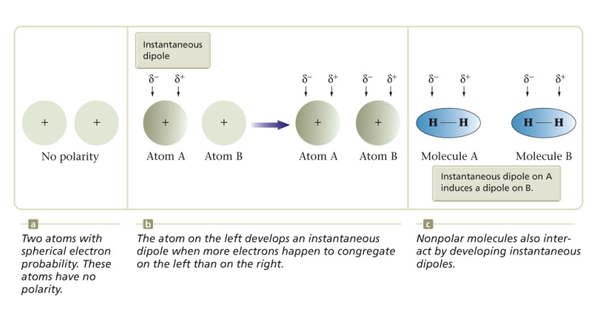
What intermolecular forces exist in the following?
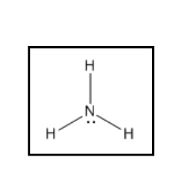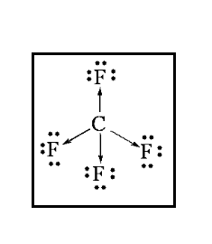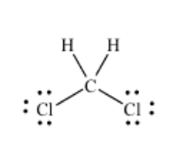

Homework: Intermolecular Forces Worksheet
Why Water is a Freak
- Recall that water is a very molecule with 2 strong
bonds.

- This gives water unique properties
  - Very strong

  - Low vapor pressure
    - Gives a melting and boiling point
  - when it freezes
    - Water expands when it freezes due to the
that forms as water molecules line up.
    - This also the density of ice by increasing the volume.
      - Does ice sink or float?

- This is a special design of God that allows aquatic
life to survive. How?

- This is also the reason that a bottle of water will
explode if put in the freezer
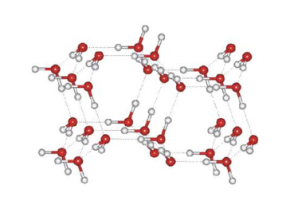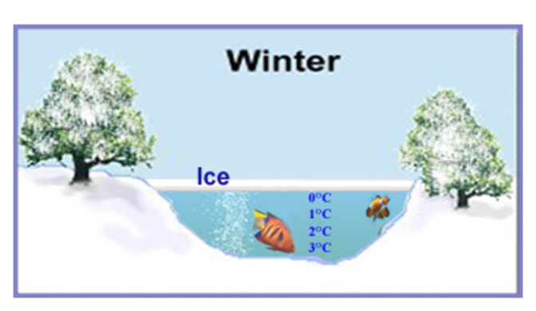

Metallic Bonding
bonding—positively charged metal ions, arranged in a lattice, are surrounded by a sea of electrons

Electrons—Valence electrons move freely around the ions and form a cloud of electrons

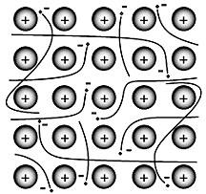

Properties of Metals
- since the atoms line up in nice, neat rows and are
attracted to the electron cloud they can slide past each
other ( , )

- since the electrons are held very weakly, they can move around easily which makes metals good

- The more delocalized electrons a metal has, the
it is and the higher melting point
  - metals tend to be stronger because their d
sublevel electrons are also delocalized electrons
  - Alkali metals have only 1 delocalized electron per
nucleus so they are

- The mobile electrons can also absorb and emit photons
of light giving metal their

Alloys
- —a mixture of elements that has metallic properties

  - is a mixture of iron chromium
and nickel
  - is copper and zinc
  - is actually gold, silver, and copper

- Alloys typically form when the ions are either very
in size or drastically

  - —atoms similar in size so one substitutes
for the other
    - Sterling silver is a mixture of copper and silver which are very close in size
    - 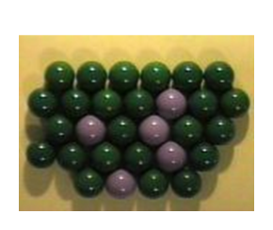
  - —One ion is markedly smaller than the other
so it fits in the spaces between
    - Carbon steel—Iron and carbon—carbon is much smaller than iron so it fills the spaces between the iron ions
    - 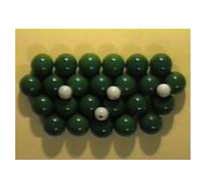
Homework: Worksheet

Chapter 15
Solutions

Solutions can be solid, liquid or gas
- Solid solutions-
- Bronze, sterling silver, brass

- Liquid solutions-most common solutions
- Water is unique because it many different substances
- A solution with water as the base is referred to as an solution

- Gaseous solutions—mixtures of gases are solutions
- is a solution of nitrogen, oxygen, and many other trace gases
Parts of Solutions
- —the majority component of the solution
- —the minority component(s) of the solution

- What is the solvent and 3 different solutes in air?

Polarity and Dissolving
- Polar solutes dissolve in solvents
- Nonpolar solutes dissolve in solvents
- “ ”

- Does sugar dissolve in water?

- Is sugar polar or nonpolar?

- Does water mix with oil? Why not?

- Would sugar dissolve in oil?

Polar molecules have partial positive and negative ends
- They have a strong for the partial positive and negative ends of other polar molecules such as
- Therefore polar molecules will attract and with other polar molecules
Nonpolar molecules only have forces therefore they don’t have a strong enough attraction to push apart the polar molecules
- They are by the attraction of a polar molecule
- Polar molecules are like a clique. They anything that is not polar like them
Rate of Dissolving
- rate can be affected by size of solute grains, stirring, and temperature
- Size of Grains- it will take less time to dissolve sugar than a large clump of sugar
- more is exposed
- more water molecules can come into more contact with the sugar molecules

- Temperature-the the temperature, the a solute will dissolve
- the molecules are moving so more
solvent molecules come into contact with more solute molecules

- also causes more water molecules
to come into contact with the solute

Relative Concentration
- Solubility—the amount of a solute
which can dissolve into a solvent at a given
temperature

- solution—a solution which contains
all of the solute it can hold at that temperature
  - solubility can be increased by
the temperature
  - saturated solutions become
when heated
  - Solubility —an equal amount of
solute is dissolving from a sample as is being re-deposited

- solution—an solution which can dissolve more solute at a given temperature

- solutions—contains more solute than a saturated solution at a given temperature
  - this is done by heating the solution then adding more solute and allowing it to
  - it will remain in solution until a is added
  - When a supersaturated solution precipitates, the energies of dissociation and hydration are
curve—a graph showing the solubility of a
substance at different temperatures.
- What is the general trend of solubility vs. temperature?

- Are there any exceptions?

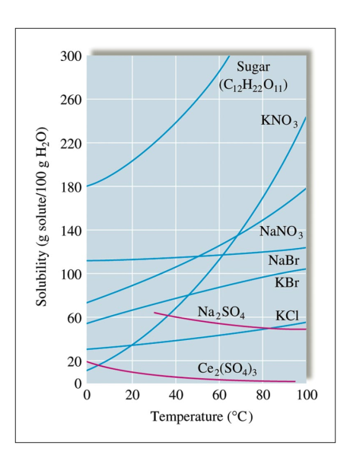

Solubility of Gases
You can dissolve more gases if you the pressure of the gas over the liquid

You can dissolve more gases if you the temperature of the liquid
- When you shake an unopened Coke bottle, what happens?
Why?
- If you want to keep the drink from going flat do you keep it on the counter or in the refrigerator?
- Why?
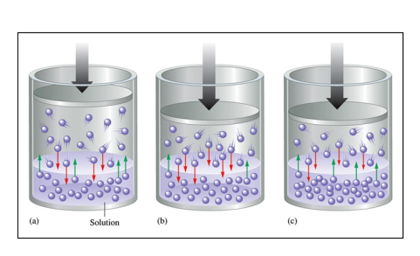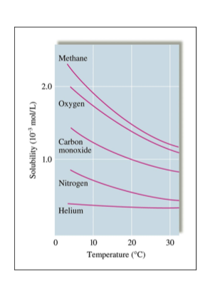
Homework: Solutions Worksheet

Concentration
—the amount of a particular substance in a given quantity of solution
Three measurements of concentration
- (M)—the number of moles of solute in a liter of solution
- (m)—the number of moles of solute in a kg of solvent
- -mass of the solute as a ratio of the mass of the solution
Molarity—the number of moles of a solute in 1 liter of solution
- M=

- How many grams of Mg(NO₃)₂ are in 493mL of a 1.385M solution?

- Exercise 15.3 pg 485
Molality (m)—the number of moles of solute dissolved in 1kg of solvent
- m=

- What is the molality of a solution if .255mol of
NaCl are dissolved in 355g of water?

- Watch out! What is the molality of a solution of KBr and water if 33.4g of KBr are in 945g of
solution?
  - You have to remove the mass of the solute
from the solvent

%mass= x 100

- What is the percent by mass of ethanol (C₆H₆O) in the final solution when 85g of ethanol is
diluted to a mass of 250g?

- Example 15.2 pg 482

- Exercise 15.1, 15.2
Homework: Concentration Worksheet

Dilutions
When you dilute a substance the amount of solvent changes but the moles of remains constant
If M=moles/L then moles=ML

${}_{}{}_{}={}_{}{}_{}$(units must match)

How many milliliters of aqueous 2.00M MgSO₄ must be diluted with water to prepare 100.0mL of aqueous 0.400M MgSO₄?

Exercise 15.7 pg 491; pg 505 55

Flip work: Kool Aid Lab Preliminary Questions

Colligative Properties
property—a property that is determined by the number of present in the system
- Covalent compounds do not therefore they only add one mole of solute
per mole of compound
  - C₆H₁₂O₆ forms mole of solute per mole of compound
- Ionic compounds dissociate into
therefore
  - KCl forms moles of ions per mole of compound
  - Ca(OH)₂ forms moles of ions per mole of compound
  - AlBr₃ forms moles of ions per mole of compound

Raoult’s Law—The vapor pressure of a liquid with the number of dissolved particles
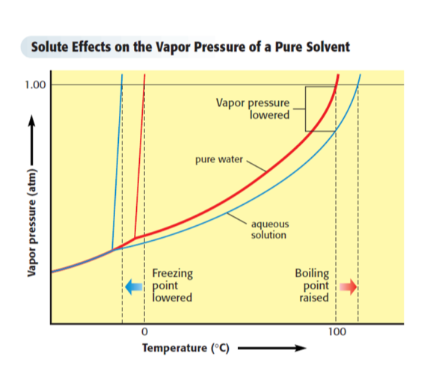
As the number of particles increases, the boiling point of a solvent

Where t=temperature, K_{b}=boiling point elevation constant for that solvent, m=molality, p=# particles dissociated
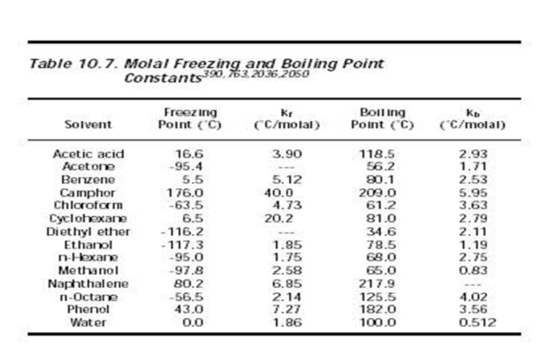
What will the new boiling point of water be if 35.62g of NaCl is dissolved in 1377g of water?

Why does your mom add salt to boiling water?
∆T=K_{b}mp
m=
∆T=
∆T=
Original boiling point of water=

New boiling point =

According to this is it practical to add salt to boiling water to raise the boiling point?

Freezing Point depression—the freezing point of a solvent decreases with the number of particles dissolve in it

Why do we spread salt on roads when it snows?

What will the new freezing point of ethanol be if
100.3g of calcium chloride are added to
2.459kg of ethanol?
∆T=K_{f}mp
m=
∆T=
Original freezing point of ethanol=

New freezing point=
Homework: Colligative Properties Worksheet

