Chapter 14
Liquids and Solids

Intermolecular Forces

- forces—forces which hold atoms together in a bond (ionic, covalent)

- forces—electrostatic attractions between molecules
  - than bonds which hold molecules in a covalent compound together

- Determines properties such as of
matter
Dipole-Dipole Forces

- Partial area of one molecule attracts the partial area of another molecule

- The stronger the (difference in electronegativity), the the attraction

- Similar to ionic bonds but much

- Occurs only in covalent molecules
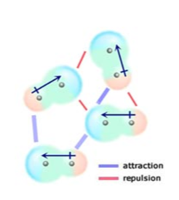

Hydrogen Bonds

- when hydrogen is bonded to a strongly electronegative element, its single electron shifts from the nucleus

- As a result the single-proton nucleus of hydrogen is
left

- Any region of another molecule can then
attract to the hydrogen

- Form when hydrogen bonds to (NOF)

- than dipole-dipole forces
- Occurs only in molecules
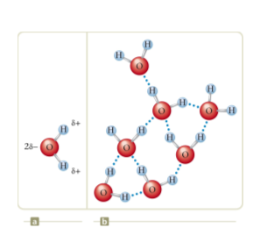
London Dispersion Forces

- bond which forms when electrons randomly end up concentrated on one side or the other of a molecule

- These temporary dipoles then a dipole on surrounding molecules

- Fairly forces of attraction

- Occur in and molecules

- Allows molecules to attract

- in atoms or molecules with more electrons
(larger molecules)

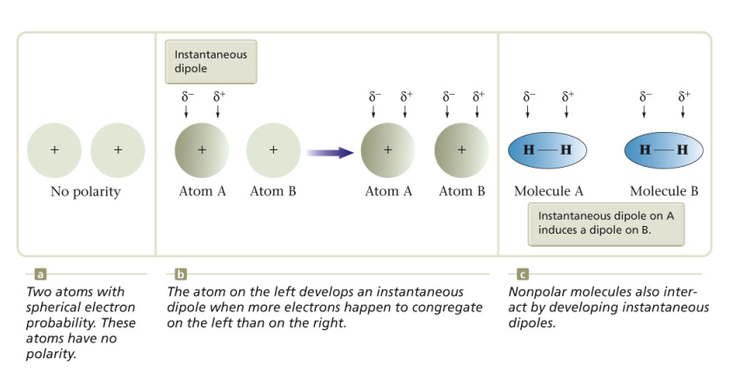
What intermolecular forces
exist in the following?
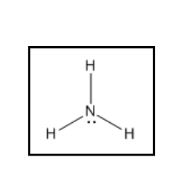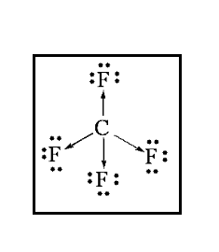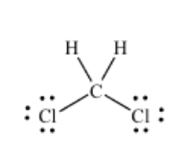

Phase Changes
Phase=State of Matter
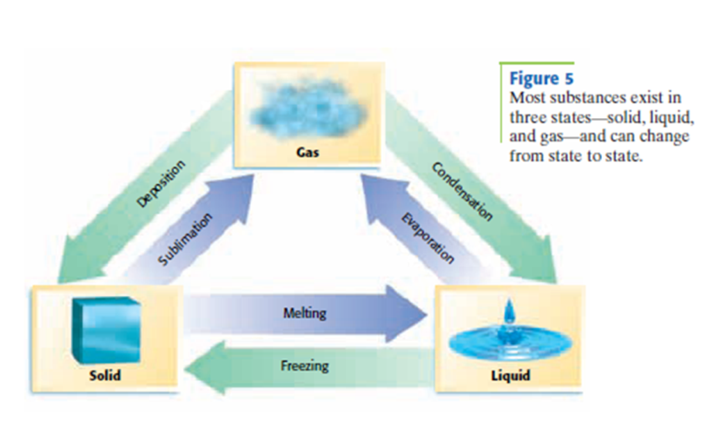
- —solid to a liquid

- —liquid to solid
  - Opposite of melting
  - Ice forming, glass hardening
  - Freezing point—the temperature at which
the liquid and solid phases can coexist
- —liquid to gas
  - When the kinetic energy of a particle gets high
enough, it can break free of the intermolecular
forces and become a gas

    - —vaporization from the surface of a
liquid
      - Evaporation absorbs energy so it is a process

- —Gas becoming a liquid
  - kinetic energy and slows to allow
intermolecular forces to act
  - Opposite of
  - and

- —solid to gas without becoming a liquid
  - Ice in a freezer will gradually lose
    - A few of the water particles have enough kinetic energy to break free from the becoming a gas

- —gas to solid
  - Opposite of sublimation
  - ,
Homework: Worksheet

Phase Changes and Energy
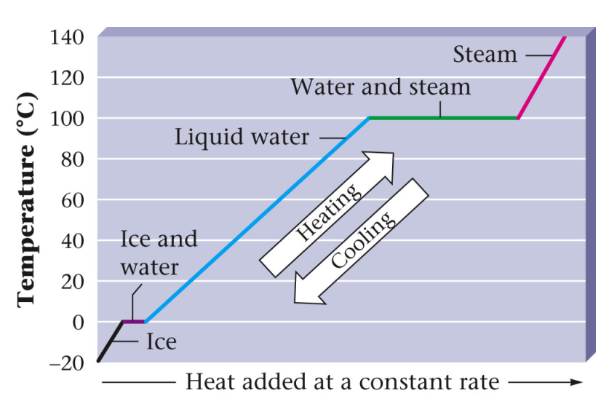

Heat of Fusion
- As ice melts, the temperature remains even though energy is still being added
- The extra energy is being used to the intermolecular forces rather than increase kinetic energy (temperature)
- Molar heat of (H_{f})-extra energy needed to melt 1 mole of a substance

- Molar heat of fusion for water=

- How much energy is necessary to melt 15.5g of ice at
0ºC?

Heat of Vaporization
- As a liquid boils, extra energy is needed to completely
the intermolecular forces to make the liquid a gas

- Molar heat of (H_{v})-extra energy
necessary to turn 1 mole of a liquid into a gas

- Would you expect this to be higher or lower than
heat of fusion? why?

- Molar heat of vaporization for water is at 100ºC

- Calculate the energy released when 35.0g of
steam turns into water at 100ºC

Calculate how much energy is necessary to heat 22.5g of
water at 0ºC to steam at 100.ºC

What changes are taking place?

1. Water is heating from 0ºC to 100ºC

2. Water becomes a gas

The total energy necessary is

Calculate the total energy required to change 15g of ice
at 0ºC to steam at 100ºC

What changes are taking place?

The total energy necessary is

Homework: worksheet

Vapor Pressure
- —the pressure a vapor exerts on the
liquid from which it came

- If a bottle is left opened, the pressure never builds up
so it will all

- If the bottle is closed, the pressure will build up until
the number of molecules the liquid equals the
number of molecules

- This pressure that builds up is
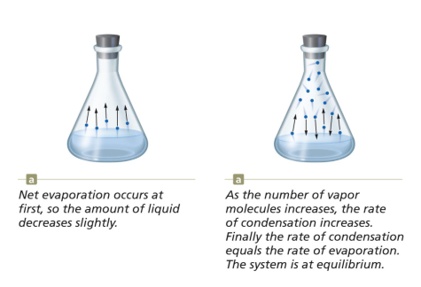

Stronger intermolecular forces will yield a lower vapor
pressure. Why?

- Which in each pair would have the higher vapor pressure?
  - H₂O or CH₃OH

  - CH₃OH or CH₃CH₂CH₂OH

Boiling
- Boiling—when the vapor pressure of a liquid equals the
pressure, the liquid will boil
- The particles the liquid have the energy
to evaporate instead of just those at the surface

- -the temperature at which the vapor pressure of water equals the vapor pressure of the atmosphere and gas a liquid can coexist
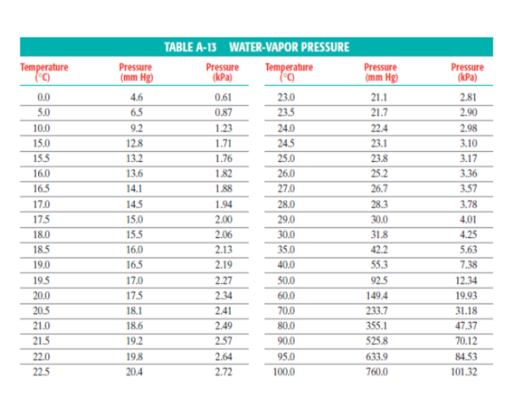
- At higher elevations, pressure is lower, what will this
do to the boiling point?
  - The boiling point will be due to the
decrease in pressure
  - This is why many food packages contain high
elevation instructions
  - The pressure on top of Mt. Everest is 58kPa.
What is the approximate temperature of boiling
water?

- Why do pressure cookers cook food more quickly?
- They the pressure of the air over the water
- The water will boil at a temperature, cooking
the food faster
Homework: Worksheet

Liquids
Particles are still held close together by forces but now can move around

- Density is similar to a solid but slightly

- Indefinite but definite

- —attraction between 2 different molecules

- —attraction between identical molecules

- If there is a intermolecular force between a
liquid and its container, the edges of the liquid will
rise up the side of the container slightly

- —a concave surface of a liquid due to
strong forces between the liquid and the
container

—resistance of a fluid to flowing
- How thick is it? The thicker, the more viscous

- 3 factors which determine the viscosity:
  - Types of intermolecular forces
    - forces between molecules gives higher viscosity
    - More of particles
  - Size and Shape of particles
    - particles tend to be more viscous
    - Long chain-like molecules such as are more viscous
  - Temperature
    - Viscosity with increased temperature
    - Is it easier to pour syrup when it is hot or cold?

—the effect of liquids have a “skin” on
their exterior surface
- due to unbalanced forces pulling towards the and no forces pulling outward

- water beads up because surface tension always
tries to surface area

- The stronger the forces in a substance, the higher the surface tension

- -substances which lower surface tension
  - are surfactants
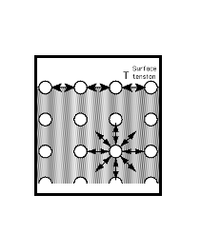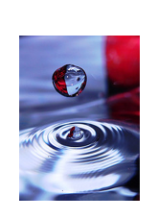
—a liquid will rise up in a narrow
diameter tube if there are strong adhesive forces
between the tube and liquid

- The height is proportional to the diameter of
the tube

- causes the liquid to move up the sides and
minimizes the surface area by bringing
the middle up
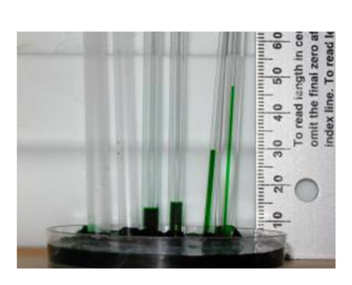
Homework: Worksheet

Solids
Particles are held very together by intermolecular forces

- density than gases or liquids

- Particles cannot move but only in
place

- volume and shape

- Usually have shape

Crystalline Solids
- Solids—a solid whose atoms, ions, or molecules are arranged in an orderly, geometric, three-dimensional structure
- -components are ions arranged in a lattice
  - NaCl, CaCO₃

- -components are molecules
(covalent compounds)
  - Ice, Sugar

- -components are atoms
  - Diamond, silicon
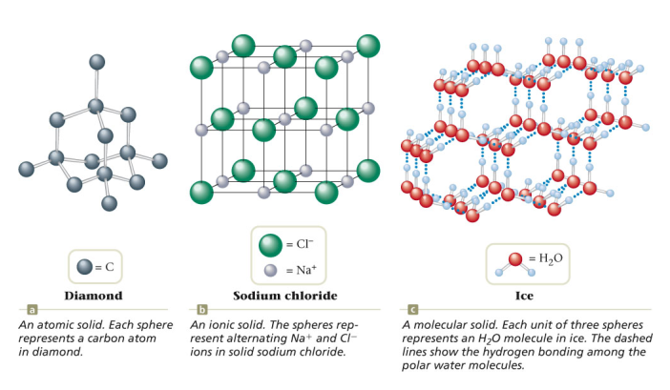
Amorphous Solids
- solid—a solid without any definite shape or crystalline structure
- no definite shape

- No definite point

  - wax, glass, rubber, plastic

- or liquid—a liquid, when cooled fast enough does not have time for the particles to be arranged
Why Water is a Freak
- Recall that water is a very molecule with 2 strong
bonds.

- This gives water unique properties
  - Very strong

  - Low vapor pressure
    - Gives a melting and boiling point
  - when it freezes
    - Water expands when it freezes due to the
that forms as water molecules line up.
    - This also the density of ice by increasing the volume.
      - Does ice sink or float?

- This is a special design of God that allows aquatic
life to survive. How?

- This is also the reason that a bottle of water will
explode if put in the freezer
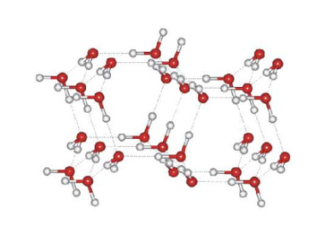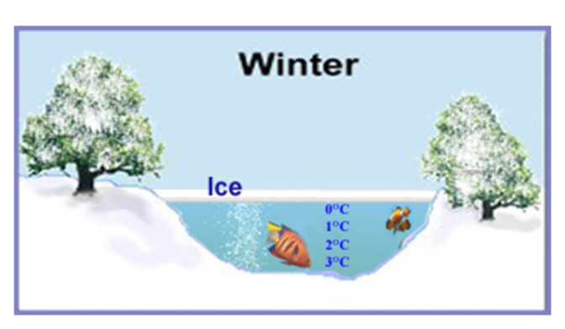
Homework: Worksheet

Metallic Bonding
bonding—positively charged metal ions, arranged in a lattice, are surrounded by a sea of electrons

Electrons—Valence electrons move freely around the ions and form a cloud of electrons

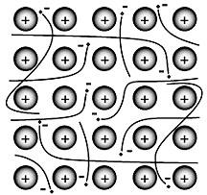

Properties of Metals
- since the atoms line up in nice, neat rows and are
attracted to the electron cloud they can slide past each
other ( , )

- since the electrons are held very weakly, they can move around easily which makes metals good

- The more delocalized electrons a metal has, the
it is and the higher melting point
  - metals tend to be stronger because their d
sublevel electrons are also delocalized electrons
  - Alkali metals have only 1 delocalized electron per
nucleus so they are

- The mobile electrons can also absorb and emit photons
of light giving metal their

Alloys
- —a mixture of elements that has metallic properties

  - is a mixture of iron chromium
and nickel
  - is copper and zinc
  - is actually gold, silver, and copper

- Alloys typically form when the ions are either very
in size or drastically

  - —atoms similar in size so one substitutes
for the other
    - Sterling silver is a mixture of copper and silver which are very close in size
    - 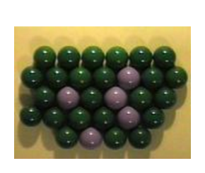
  - —One ion is markedly smaller than the other
so it fits in the spaces between
    - Carbon steel—Iron and carbon—carbon is much smaller than iron so it fills the spaces between the iron ions
    - 