Chapter 12
Chemical Bonding
Bonding and Energy
Chemical bond—the force of that holds atoms together in a compound

Based largely on electron structure

Would sulfur or nitrogen bond similarly to oxygen? Why?

-energy required to a bond
This is also the energy released when a new bond forms

If the energy to break the bonds is than the energy released when new bonds form then the reaction is

Types of Bonds

will pull electrons off of metals and keep them.
bond—a bond in which valence electrons are transferred from one atom to another
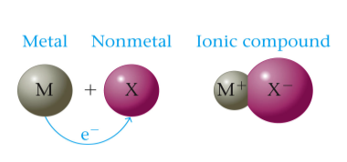

with other nonmetals will both refuse to let go of electrons so they will
bond—a bond in which valence electrons are shared tightly between atoms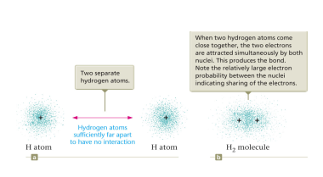

Electronegativity

Electronegativity-the relative ability of an atom in a molecule to electrons
How hard the atom on other electrons
Arbitrary numbers based on comparisons between elements
Fluorine has the maximum value of
all others are
from left to right—nuclear charge
top to bottom—electron
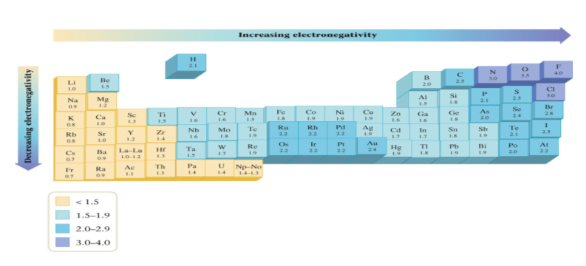
The type of bond is somewhat of a continuum
There is no set line distinguishing an from a polar covalent and a covalent bond

It is a more subtle difference
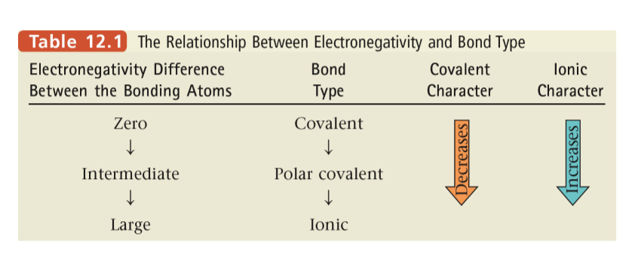
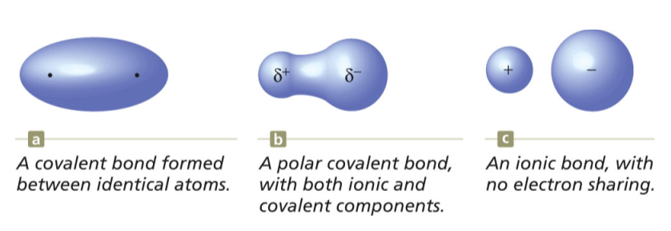
Bonding Energy
Covalent bonds are a balance of forces
between a nucleus of one atom and the valence electrons of another

of two nuclei

Ionic Radius

anions are than their parent atoms because there is one more charge than positive charge, allowing them to spread out

cations are than their parent atoms because there is one more than negative, allowing them to attract more strongly

Ionic Structure

Ions arrange themselves in a to minimize the amount of potential energy
-the empirical formula of an ionic compound
There are no discrete units of ionic compounds

Polyatomic Ion Structure
The ion as a unit forms structures similar to compounds

the atoms within the polyatomic ion are bonded

Lewis Structures
Consists of the symbol of the element with dots surrounding it

There are the same number of dots as electrons

Place dot on each side before placing on any side

What is the dot structure for :

Strontium

Oxygen

Neon

Hydrogen and Helium obey the
duet rule-elements are stable when they have valence electrons

Most other elements obey the
octet rule-elements are stable when they are surrounded by valence electrons

Shared pairs of electrons are referred to as

Pairs of electrons which are not involved in bonding are referred to as

How many bonding pairs and lone pairs of electrons are in the following Lewis structure?
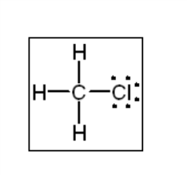
covalent bonds—one pair of electrons is shared
indicated by a pair of dots or a single

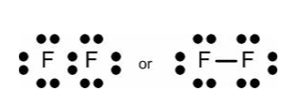
covalent bond—two pairs of electrons are shared
indicated by a double
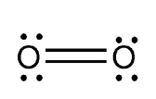

covalent bond—three pairs of electrons are shared
indicated by a triple
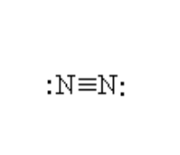
In general, atoms make the same number of covalent bonds as they want to gain electrons to become

Iodine makes bond

Sulfur makes bonds

Phosphorus makes bonds

Carbon makes bonds

Hydrogen makes bond

Lewis Structures
- Predict the of atoms
  - The atoms with the electronegativity generally go in the
  - Hydrogen always goes on the
- Find the number of valence electrons in the molecule
- Start by placing bonds between each pair of atoms
- Place electrons around each atom until they have a complete
- If you end up with more electrons in the molecule than you have valence electrons from step 2 add bonds
  - For each pair of extra electrons, you must add multiple bond
- Place the bond on the element which wants another bond

Draw the structure of CCl₄ on paper
Draw the structure of CS₂ on paper
Draw the structure of CF₂O on paper

Polyatomic ions
Works the same as regular Lewis structures but the number of valence electrons is increased or decreased by the on the ion

SO₄²⁻ electrons

NO₃⁻ electron

NH₄⁺ electron

Draw the structure of SO₂²⁻ on paper
Draw the structure of NO₃⁻ on paper
Draw the structure of NH₄⁺ on paper
Resonance
When more than one Lewis structure is possible
Draw resonance structures for the following

SO₂

NO₂⁻

Exceptions to the octet rule
- Odd number of valence electrons

NO₂

- Fewer than 8 electrons (Boron and Beryllium)
  - very reactive compounds
BH₃

BeF₂

- More than 8 valence electrons
  - sublevel holds the extra electrons
  - Can only exist in period or higher
  - Extra electrons go on atom

Which of these can make an expanded octet?
N, F, I, S

XeF₄

Molecular Structure
theory
Valence Shell Electron Pair Repulsion theory
based on the principle that try to get as far away from one another as possible

Electron -an area around the atom in which groups of electrons are found
- are electron concentrations
  - Single, double and triple bonds are all concentration
- are electron concentrations

- 2 electron concentrations will repel each other as far away as possible which would be º

This would give a shape to the molecule

- 3 electron concentrations will repel each other as far away as possible which would be º

This would give a shape

If only two of those electron concentrations are bonding pairs then the shape of the molecule would be described as .

- 4 electron concentrations will repel each other as far away as possible which would be º

This would give a shape

If only three of those electron concentrations is a bonding pair then the shape of the molecule would be described as a

If there are only two bonding concentrations it is

- 5 electron concentrations would have a structure called a

The equatorial atoms are separated by º

The polar atoms are separated by º from the equatorial atoms

There are two bond angles here: º and º

for our purposes we will call all molecules with 5 electron concentrations trigonal bipyramidal

- 6 electron concentrations will repel each other as far away as possible which would be all º

This would give an shape

For our purposes all molecules with 6 electron concentrations will be octahedral

Any diatomic molecule will have a linear shape
VSEPR Geometry Table
Electron Concentrations | Bonding Concentrations | VSEPR Geometry | Picture
2 | 2 |  | 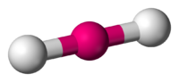
3 | 3 |  | 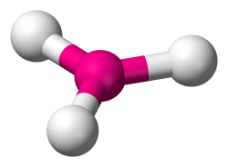
3 | 2 |  | 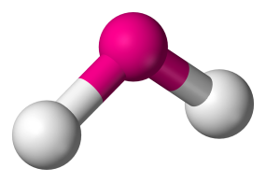
4 | 4 |  | 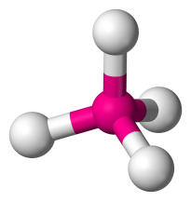
4 | 3 |  | 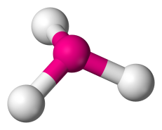
4 | 2
5 | Any* |  | 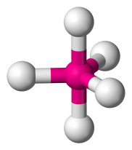
6 | Any* |  | 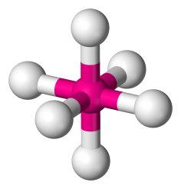
Any Diatomic Molecule |  |  | 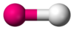
*Not really but for our purposes we will call all 5 e.c. molecules the same

Molecular Polarity
Molecules are not always

Linear bonds are polar if the atoms have electronegativities

Trigonal planar molecules are polar unless all three outer atoms have electronegativity

Tetrahedral molecules are polar unless all 4 outer atoms have electronegativity

Trigonal bipyramidal molecules are unless all 5 outer atoms have the same electronegativity

Octahedral molecules are unless all 6 outer atoms have the same electronegativity

Trigonal pyramidal molecules are polar

Bent molecules are polar

Dipole Moment

Polar molecules have what is called a

dipole moment-a property of a molecule that has a center of charge and a center of charge

indicated as an arrow with a cross at the tail
Arrow points toward center (more electronegative end)
Cross is at center (less electronegative end)

Draw the following Lewis structures. Indicate the dipole moment if it is present

NH₃

XeF₆

CF₂S

