Chapter 11
Modern Atomic Theory
Rutherford's Atom
- Rutherford demonstrated the presence of a dense
- Later he discovered that the nucleus was made of positive and neutral
- Thomson had already proven the presence of
- What he could not explain was why the electrons did not into the nucleus due to charges
There was a lot more to learn about the behavior of electrons
Electromagnetic Radiation
- Electromagnetic Radiation-energy that exhibits -like behavior and travels at the of light in a vacuum
- There are many forms of electromagnetic radiation. light is a tiny proportion
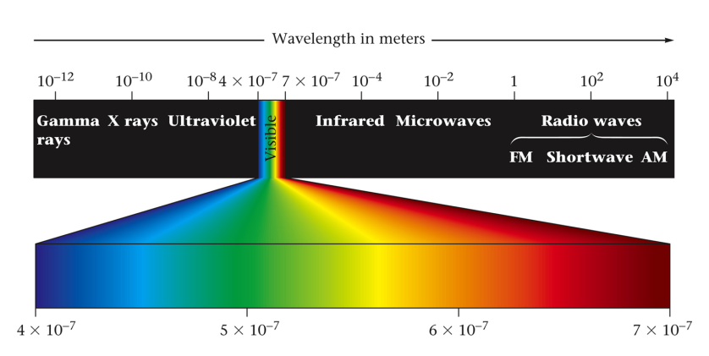
Properties of waves
- Moves , not matter
- -distance between two consecutive peaks on a wave
- -the number of peaks that pass through a point in a given amount of time

- Speed-how a peak moves through a medium

- Wavelength and frequency determine what of radiation you have
Albert Einstein
Light behaves both as a and as a
—A of electromagnetic radiation with no mass that carries exactly one (a packet) of energy
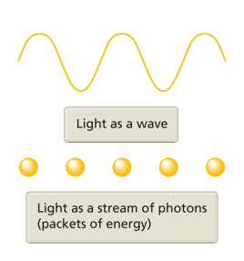
Nature of EM Radiation
So is light a wave or a particle?
the the wavelength of light, the energy the photons carry
Homework: pg 392(1, 3-8)

Atomic Emission Spectra
- Each element will emit certain wavelengths of when the atoms are
  - Neon lights based on this principle
- Atomic emission —the set of wavelengths of the electromagnetic waves emitted by atoms of an element
  - Each has a characteristic atomic emission spectrum
  - This puzzled physicists and chemists because they expected a spectrum like white light
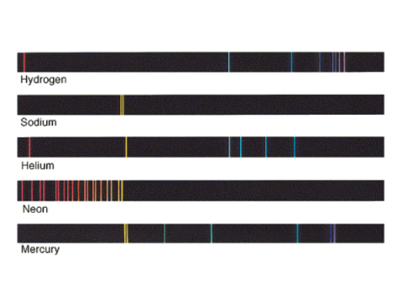
Hydrogen Emission Spectrum
- The spectrum is discontinuous
  - The electron begins in the state—the allowable energy level
  - There are certain orbits that the electron can occupy if excited with energy— state
- As that electron falls back down, it light with a wavelength=the between the levels
  - Light falling from n=6 has energy than light falling from n=3 so it will have a
wavelength
Similar to the rungs of a ladder
- If you energy, you can climb up a ladder, touching each rung
- If you go down the ladder, you energy as you go down
- Is it possible to stand between rungs on a ladder?
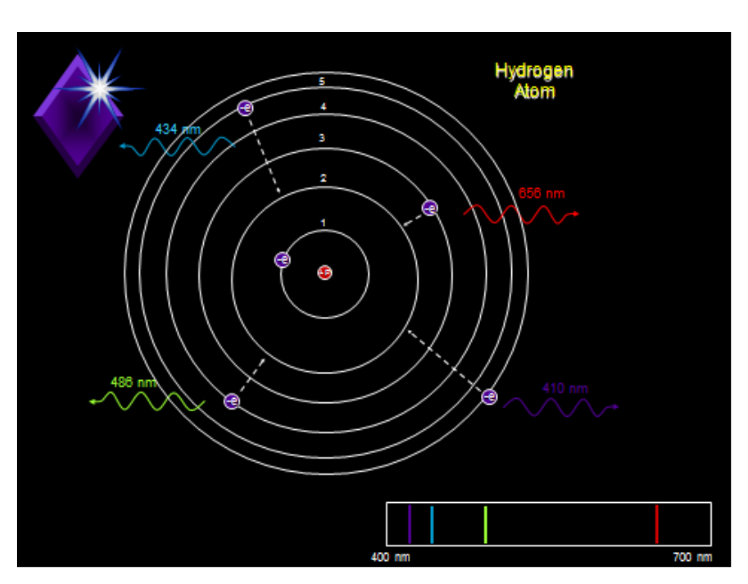
Bohr's Model
- Based on a line spectrum given off by
- Atoms contain circular called energy levels in which electrons can be found
- These energy levels are -only certain values are allowed

- Moving between different energy levels gives off light at different wavelengths (colors) so each element has a line spectrum
Problem: This model only worked for hydrogen with 1 electron
Homework: pg 392 (10-12, 14, 16, 18-20)
Wave Mechanical Model
- Just as light has a dual nature electrons behave both as and as well.
- We can only know the location of an electron
  - There is no way to predict the of an electron
  - Electrons do not travel in circular
Electrons travel in
- —a three dimensional area around the nucleus which describes an electron’s location
- The probability of an electron being found in a given orbital is about 
Energy Levels
- Energy Level-discrete energy level an electron can occupy
- Each Principal energy level is divided into
- Each sublevel is divided into a certain number of
- Each orbital holds electrons
Energy Levels
- S Sublevel
- shape
- orbital
- Holds electrons
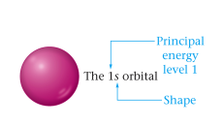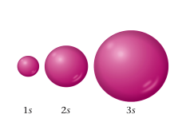
- P sublevel--first found in energy level
  - shape
  - orbitals
  - Holds electrons
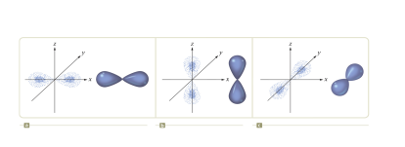
- D sublevel—first found in energy level
  - Orbitals
  - Holds electrons
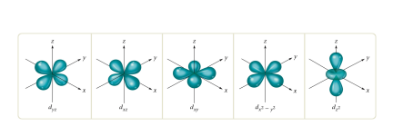
- F sublevel—first found in energy level
  - Orbitals
  - Holds electrons
Aufbau Principle
Each electron occupies the energy orbital available
- Sublevels within a principal energy level have different
- 2s has energy than 2p sublevel
- The sequence of sublevels in order of increasing energy within an energy level is
All orbitals related to a given sublevel are of energy
- All 3 orbitals in the p sublevel have the energy
Orbitals related to energy sublevels within one principal energy level can orbitals of a sublevel in a different principal energy level
- They do not fill in the order
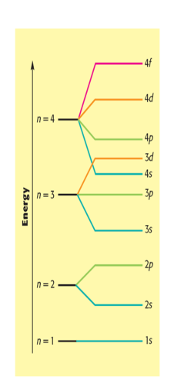
Pauli Exclusion Principle
- Electrons one of two ways
- This is indicated by an up (↑) or down (↓) arrow
- There can only be electrons occupying an orbital if they have spins
Hund's Rule
- As electrons fill the sublevels, all orbitals receive electron before any receive
  - This is due to the on electrons
  - To fill the p sublevel, first each orbital must receive one electron, then they can start filling in the second
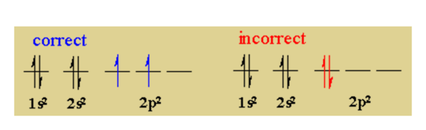
Order Electrons Fill Orbitals
Not all energy levels have all sublevels
1st energy level has only an S sublevel
2nd has S and P sublevels
3rd has S, P and D sublevels
4th and higher have S, P, D, and F sublevels

1s
2s 2p
3s 3p 3d
4s 4p 4d 4f
5s 5p 5d 5f
6s 6p 6d 6f
7s 7p 7d 7f
rule—draw diagonal lines from top right to bottom left. The sublevels fill in the order the lines touch them.
Homework: pg 392 (21, 22, 24, 26-29)

Electron Arrangements (this will probably be easier on paper)
the electrons of hydrogen can be indicated in 2 ways:
Electron configuration

where the is the principal energy level, the letter is the , and the superscript is the number of in that sublevel.

Orbital diagram (box diagram)
1s

where the is indicated over the top and the number of in each sublevel is indicated by the blanks underneath and are represented by arrows which alternate up and down
Electron configuration of Chlorine can be written as:
Electron configuration:
↑↑↑↑↑↑↑↑↑↑↑↑↑↑↑↑↑↑↑↑↑↑↑↑↑↑↑↑↑↑↑↑↑↑↑↑↑↑↑↑↑↑↑↑↑↑↑↑↑↑↑↑↑↑↑↑↑↑↑↑↑↑↑↑↑↑↑↑↑↑↑↑↑↑↑↑↑↑↑↑↑↑↑↑↑↑↑↑↑↑↑↑↑↑↑↑↑↑↑↑↑↑↑↑↑↑↑↑↑↑↑↑↑↑↑↑↑↑↑↑↑↑↑↑↑↑↑↑↑↑↑↑↑↑↑↑↑↑

↓↓↓↓↓↓↓↓↓↓↓↓↓↓↓↓↓↓↓↓↓↓↓↓↓↓↓↓↓↓↓↓↓↓↓↓↓↓↓↓↓↓↓↓↓↓↓↓↓↓↓↓↓↓↓↓↓↓↓↓↓↓↓↓↓↓↓↓↓↓↓↓↓↓↓↓↓↓↓↓↓↓↓↓↓↓↓↓↓↓↓↓↓↓↓↓↓↓↓↓↓↓↓↓↓↓↓↓↓↓↓↓↓↓↓↓↓↓↓↓↓↓↓↓↓↓↓↓↓↓↓↓↓↓↓↓↓↓
Orbital Diagram:
1s 2s 2p 3s 3p
__ __ __ __ __ __ __ __ __

Look at Carbon

1s 2s 2p
__ __ __ __ __

Write the electron configuration of Antimony

Write the orbital notation of Antimony

1s 2s 2p 3s 3p 4s 3d
__ __ __ __ __ __ __ __ __ __ __ __ __ __ __

4p 5s 4d 5p
__ __ __ __ __ __ __ __ __ __ __ __
Homework: pg 393 (37-39)
Electron Arrangements and the Periodic Table
- Look at the periodic table. Where do you see a group of 2 columns?
  - This is the block
- Where do you see a group of 6 columns? 10 columns? 14 columns?
  - These are the blocks
- The on the table is the highest energy level
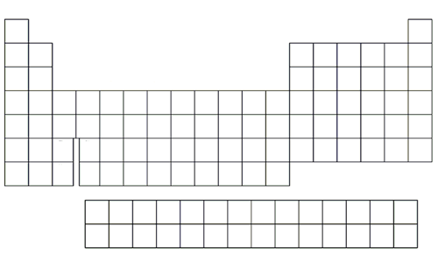

What are the electron configurations of Strontium (Sr), Bromine?(Br), and Manganese (Mn)?
Sr-

Br-

Mn-

Homework: worksheet
Noble Gas Notation
Noble gas (shorthand) notation—Start at the noble gas in the row ?immediately preceding your element, put the symbol in brackets, and ?finish the electron configuration
Chlorine (Cl) can be written shorthand using the last noble gas before it (Ne)

Palladium (Pd) can be written:

What is the noble gas notation for hafnium?

Valence Electrons
- electrons—electrons in the principal energy level
  - In the electron configuration, these are all of the electrons that have the highest coefficient
  - It will always be between
  - It will always be electrons in the s and p sublevels. Why?
    - These are referred to as the main-group or representative elements
How many valence electrons are in:
Oxygen
Calcium
Xenon
Valence electrons are incredibly important as they are the electrons that determine characteristics
Homework: worksheet
Periodic Properties and Trends
- General trends
  - Metals electrons
    - The most chemically reactive metals are in the lower of the table
  - Nonmetals gain electrons
    - The most chemically reactive nonmetals are in the upper of the table?
Trends on the periodic table happen for 2 primary factors
- Across a period the atomic number
  - The number of increases
  - The pull of the increases

- Down a group, the energy level
  - The from the nucleus increases
  - The pull on electrons
    - Electron —electrons in lower energy levels “take the hit” and block some of the attractive force from the outer electrons
Ionization Energy
- Ionization energy—minimum energy required to one electron
- “just try to take my electron”
- left to right—nuclear increases
- top to bottom
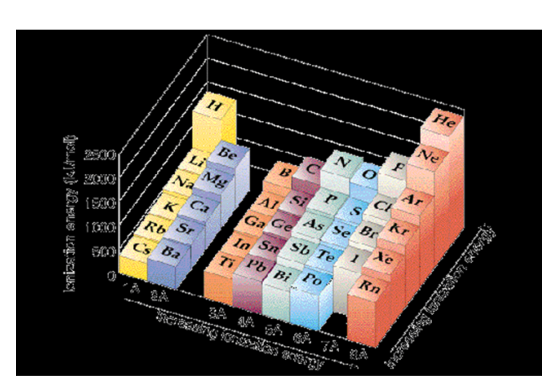
Each successive ionization energy is . Why do you think this is?
Why do you think there is a large jump in ionization energy along the line?
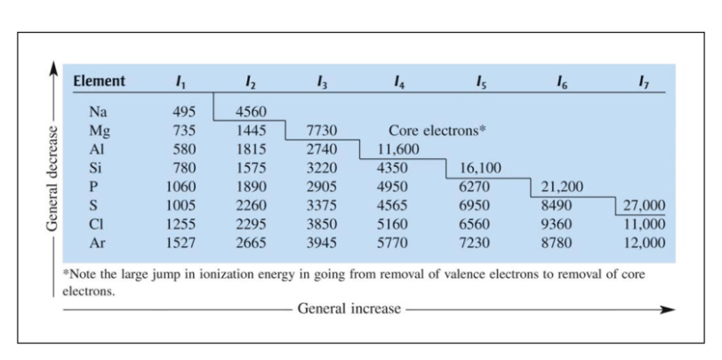
Atomic Radius (size)
- left to right due to attractive forces between extra protons and electrons
- down the groups due to more energy levels being added
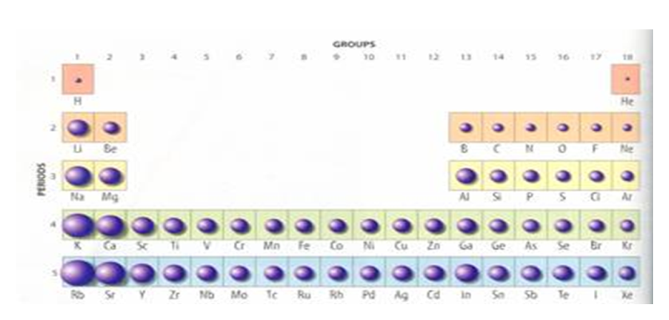
Which element has the largest radius?
N or P
Ca or Ge
Br or Ar
Ca or Cs
Which element has the higher ionization energy?
N or P
Ca or Ge
Br or Kr
Ca or Ca²⁺
Homework: Worksheet

