Chapter 10
Energy
- Energy—the capacity to do or produce heat

- First Law of thermodynamics—energy can be from one form to another but not or
- The energy of the universe is

energy—energy to to position or composition
- A person on top of a ladder has potential due to

- Gasoline has potential due to

energy—Energy due to the of an object

- KE=

- which is a larger component, mass or velocity?
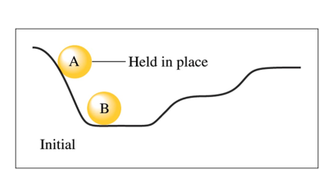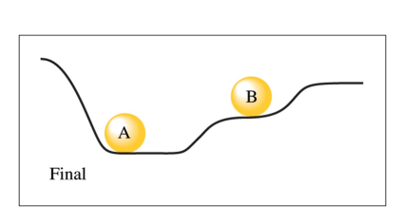
- How does the potential energy of A change?

- Why does the position of B change?

- How does the final position of B compare to the initial position of A?

- Why does this not support the 1st law of thermodynamics?

- What is an explanation for the difference?

- After A has rolled down the hill, the energy lost by A has been converted to random motions of the components of the hill ( heating) and to the increase in the energy of B.

functions—a property that depends only on its present state
- and are irrelevant
- Changes are independent of the taken
- When driving from here to Ashville, the will change the same amount regardless of which roads you take but the travelled can differ greatly

- is a state function

- is not

- Change in is a state function
  - the change in energy is the same regardless of what that energy takes

Distinguishing temperature and thermal energy
- Temperature- a measure of the random motions of the particles in a substance
  - the kinetic energy of the particles

- Thermal energy is the kinetic and potential energies of all the particles

- If a lead BB was heated to 395K and a lead safe was kept at room temperature, the BB would have a higher temperature because its particles would have a higher average KE but the safe would have more thermal energy because it has so many more particles so the total KE is higher

- Heat-the of energy due to a temperature difference

  - always flows from and stops when the temperatures are

System and Surroundings
Anytime we discuss a chemical reaction we must divide the universe into parts

- —the part of the universe we wish to look at

- —everything else

You get to define what these are

For each of the following, define a system and its surroundings and give the direction of energy transfer.
- Methane is burning in a Bunsen burner in a laboratory.

- Water drops, sitting on your skin after swimming, evaporate.

- Two chemicals mixing in a beaker give off heat.

Homework: pg 353 (1-7, 9)

Exothermic Vs. Endothermic
- Exothermic—energy (q) flows of the system resulting in the of heat
  - The energy of the system is transferred to the
  - q is

- Endothermic—energy (q) flows the system resulting in the of heat
  - The energy of the surroundings is transferred to the
  - q is

Classify each process as exothermic or endothermic and give the sign for q.
Explain.
- Your hand gets cold when you touch ice.

- The ice gets warmer when you touch it.

- Water boils in a kettle being heated on a stove.

- Water vapor condenses on a cold pipe.

- Ice cream melts.

Units of energy
- calorie-the amount of energy necessary to raise of water (metric unit)
- Calories (note the capital C) in food are actually or

- Joule-the SI unit of

- How many joules of energy are in 60.1calories?

- How many food Calories are in 1256J of energy?

Specific Heat Capacity
- Specific Heat Capacity—the amount of energy needed to raise the temperature of of a substance one (or ºC)
- measured in J/gK or J/gºC

- Specific heat of water is .

- Specific heat of rubbing alcohol is —it takes less
energy to heat up alcohol so it heats more

- The energy necessary to change the temperature of a substance depends on 3 things:
- heat capacity of the substance
- of the substance
- how much the changes
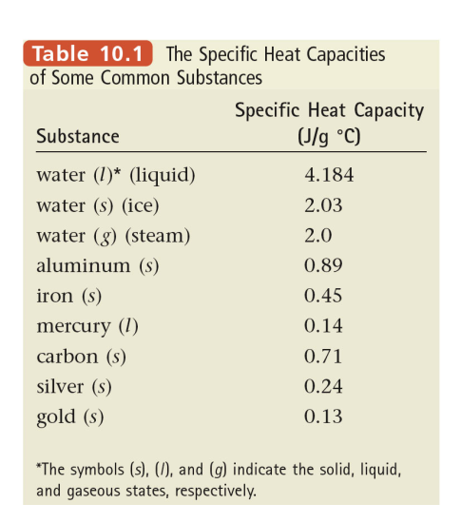
Specific Heat Capacity

q=sm$∆$T

- q=energy
- m=mass
- s=specific heat capacity
- $∆$T=change in temperature

What quantity of energy, in calories, is necessary to raise
a 1.3g piece of iron from 25⁰C to 46⁰C?

Is this an endothermic or exothermic process?

Specific Heat Capacity

A 5.63g sample of gold is heated from 21⁰C to 32⁰C. How much energy, in joules, is necessary?

A 2.8g sample of a pure metal requires 10.1J of energy to change its temperature from 21⁰C to 36⁰C. What is the metal?

Homework: pg 353 (13, 14, 23, 25-28)

Enthalpy

Enthalpy (H)—The content of a system at constant pressure

- Impossible to measure the energy in a sample
- This would mean measuring the kinetic energy of every in the object
- We must measure the in energy

$∆$H= (units kJ/mol)

When 1 mole of methane burns, 890kJ of energy are released as heat. Calculate $∆$ H for the combustion of 5.8g of methane at constant pressure.

pg 334 exercise 10.5

Change in enthalpy is a function
- Often reactions take place in multiple steps

N₂ + 2O₂ 2NO₂ actually takes place in 2 steps

1st: N₂ + O₂ 2NO
2nd: 2NO + O₂ 2NO₂

Look at the net reaction

Because enthalpy is a state function then the energy change of the reaction is the same as the energy changes of each individual reaction

N₂ + 2O₂ 2NO₂ $∆H=68$kJ

1st: N₂ + O₂ 2NO $∆H=180$ kJ
2nd: 2NO + O₂ 2NO₂ $∆$H=-112kJ
$∆$H=

Therefore, if we know the enthalpies of the in a reaction, we can find the enthalpy of the entire reaction

Two things can change $∆$H for a reaction

1. If the reaction is , the of $∆$H changes

2. If the reaction is by a coefficient, the value of $∆$H is by the same coefficient

Now this is like a puzzle. You have to figure out how to write the steps of a reaction to get the reactants and products you want
C_{(s, diamond)}→C_{(s, graphite)}

2 steps:
C_{(s, graphite)} + O₂ → CO₂ (∆H=-393.5kJ)
C_{(s, diamond)} + O₂ → CO₂ (∆H=-395.4kJ)

Notice that if the first reaction is reversed, graphite is in the products
When an equation is reversed, the sign of ∆H is changed
CO₂ → C_{(s graphite)} + O₂ (∆H= )

The combined reaction is now:
C_{(s diamond)} + O₂ + CO₂ → C_{(s graphite)} + O₂ + CO₂
Anything on both sides cancels out and now the enthalpies can be added
-395.4kJ+393.5kJ=

This is a slightly process

From the following heats of reaction:

2 H₂ (g) + O₂ (g) 2 H₂O (g) ∆H = -483.6 kJ
3 O₂ (g) -> 2 O₃ (g) ∆H = +284.6 kJ

calculate the enthalpy of the reaction:

3 H₂ (g) + O₃ (g) 3 H₂O (g)

Circle the reactants and put a square around the products in the individual reactions

H₂ and O₃ need to be in the . needs to be reversed.

What does each reaction need to be multiplied by to get the correct coefficients?

(2 H₂ (g) + O₂ (g) 2 H₂O (g)) ∆H = -483.6 kJ)
(2 O₃ (g) 3 O₂ (g) ) ∆ H = (-284.6 kJ)

Given the following data:
N₂ (g) + O₂ (g) 2 NO (g) ∆ H = + 180.7 kJ
2 NO (g) + O₂ (g) 2 NO₂ (g) ∆ H = - 113.1 kJ
2 N₂O (g) 2 N₂ (g) + O₂ (g) ∆ H = - 162.3 kJ

Use Hess’s law to calculate ∆H for the reaction.
N₂O (g) + NO₂ (g) 3 NO (g) ∆ H =

pg 337 exercise 10.6

Day 1:
Homework: pg 354 (29, 30, 32-35)

Day 2:
Homework: Worksheet

Useful energy

If energy is never destroyed, why are we worried about using it efficiently?

- Bunsen burners have a lot of potential energy. When the fuel is burned, what happens to the energy?

- Is this energy now useful?

As energy is used the does not change but the (usefulness) decreases

How energy relates to reactions

- Reactions are favored by two conditions

  - spread-concentrated energy becoming dispersed
    - reactions spread energy

  - spread-particles of matter spread out and occupy a larger

Think about combustion
- What happens to energy in combustion?

- What happens to matter in combustion?

- Do combustion reactions go in reverse?

Salt dissolving is an endothermic process. Why does it happen?

- What happens to the particles when salt dissolves?

- The effect of matter spread is than the energy concentration so the reaction occurs by itself

Entropy

Entropy—a measure of in a system

2nd law of thermodynamics
- The entropy of the universe in constantly
- Everything proceeds towards

Think about your room, if left alone, does it tend to become neater or messier?

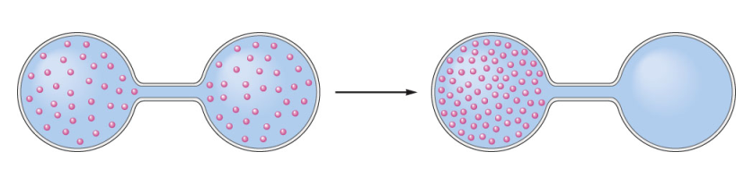
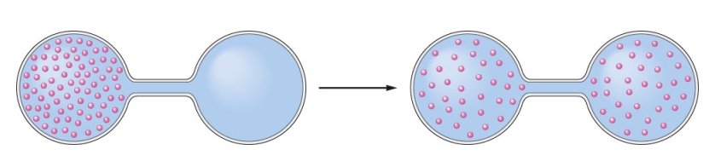
Entropy

Positive entropy means entropy is

- reactions increase the random motions of the particles

- When spreads it increases the entropy of the particles

Negative entropy means entropy is

- endothermic reactions the random motion of the particles

- when matter is compressed it the entropy of the particles

Entropy

Would entropy be positive or negative in the following examples?

- evaporation of alcohol

- freezing of water

- AgCl(s) Ag⁺(aq) + Cl⁻(aq)

- 2H₂(g) + O₂(g) 2H₂O(g)

- H₂O(l) H₂O(g)
- 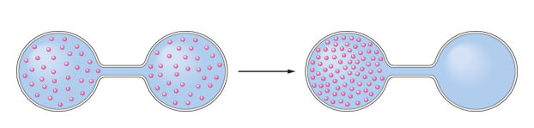

Process-a process that occurs without outside intervention (total entropy increases)

- processes (energy spread) are favorable

- spread-components are dispersed and increases entropy and is favorable

Some reactions are mixed

Suppose a reaction is but the matter becomes more such as freezing of iron
- the reaction will be spontaneous if the exothermic energy is than the compression of matter
Homework: pg 354 (36, 37, 41-44, 60)

